Tempus Resource

Quick Reference Guide

Project Manager & Service Manager (PM/SM, Blended PM/SM + PPM)
Knauf · Phase 1 · Planner Onboarding
Note: This guide focuses on the day-to-day Planner workflow for PM and SM (and Blended PM/SM + PPM). Resource Managers (RM) and Bulk Project Allocation are out of scope for this release and will be covered in a separate guide.

Contents

How to Use This Guide
PM/SM | Blended PM/SM + PPM

This guide is built for Planners at Knauf — Project Managers (PM), Service Managers (SM), and the Blended role (PM/SM + PPM). It walks you through the two workflows you will use every day:
1. Create a project — set it up so that the right people, dates and money land in Tempus from day one.
2. Find an existing project and edit it — the same set of pages, just in update mode.
Every workflow ends in the same three pillars. Master them once, and the rest is repetition:
Pillar | What it answers | Where you do it
Attributes | What is this project? (Owner, Phase, Business Unit, Dates, Tags …) | Attributes page
Resources | Who and how much? (named people, generic demand, time grain) | Single Project Allocation grid
Financials | What does it cost? (Hourly Rate, Cost Plan, Budget, Actuals) | Financials page

Tip: Whenever a step says "do the same thing later when editing", you can jump straight to the relevant pillar chapter — chapters 5–7 are written so they work for both Create and Edit.

Roles in This Guide
Role | What you will plan | In this guide
PM — Project Manager | Standard projects (Intake → Active → Closed) | Full scope
SM — Service Manager | Services / non-project activities (Run, Admin, Change) | Full scope; "Service" vs. "Project" differences flagged inline
Blended PM/SM + PPM | Both, plus Portfolio overview | Full scope; PPM cross-references at end of each chapter

Out of scope here: Resource Manager (RM) workflows (Bulk Project Allocation, Resource Replace, Heatmap administration). A dedicated RM guide will follow.

Time Grain Defaults — set these once
Time grain and capacity unit are the two settings that change how every grid in Tempus looks. The Knauf defaults are:
Setting | Knauf default | Where to change
Time granularity | Month | SPA grid → ribbon above the timeframe
Capacity unit | Hours (PM/SM views also show Mandays) | SPA grid → ribbon above the timeframe
Working hours / day | 8 h | Configured globally (admin-only)
Working hours / month | ~168 h (varies per German public-holiday calendar) | Configured globally (admin-only)

Note: If you change time grain or capacity unit on the SPA grid, the change is per view, per user — it does not affect anyone else.

Sign-in and Homescreen

Logging in
Tempus Resource is reached via the Knauf Tempus instance at knaufdev.tempus-resource.com (DEV) or the production URL once go-live is finalised.
How to
1. Open Google Chrome (recommended browser).
2. Navigate to the Tempus URL provided by your Knauf admin.
3. Click Knauf SSO Login — you will be redirected to the Knauf identity provider.
4. Enter your standard Knauf credentials. Multi-factor follows the standard Knauf policy.
5. You land on the Tempus Homescreen.

Note: If the SSO redirect fails, click Or use other methods and request a local fallback from the Tempus admin. PM/SM do not have shared accounts — each Planner signs in with their own identity, which also drives the "my projects" filter on the grid.

PM/SM Homescreen
After login you land on a focused Homescreen. PM/SM see two main tiles plus the standard top bar:
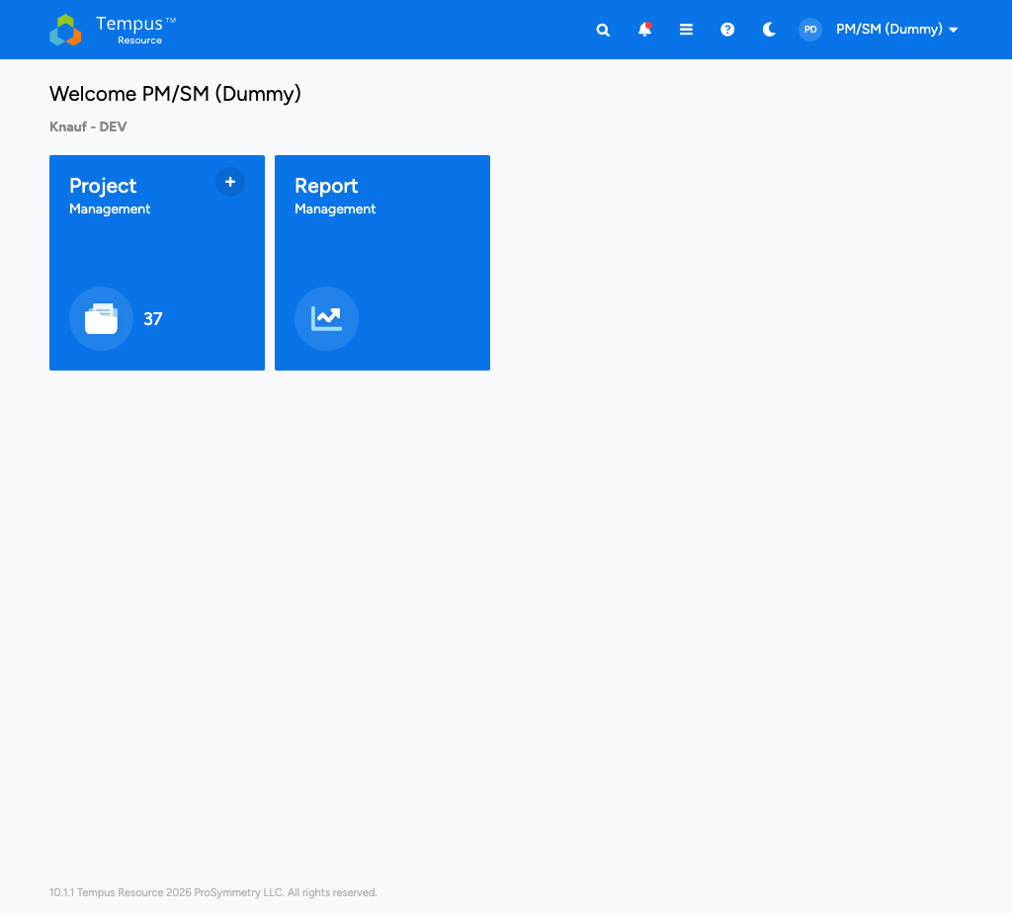
PM/SM Homescreen with two tiles
At a glance
• Project Management tile — opens the Project Management Grid (your starting point for "find a project").
• The + badge on the tile opens the Create Project dialog directly without going through the grid first (see chapter 4).
• Report Management tile — opens your subscribed and saved reports.
• Top bar with global search, notifications, help, the hamburger menu and your profile.

Note: If your Knauf account also carries the PPM role, you may see an additional Portfolio Overview tile. RM tiles (Resource Management, Bulk Project Allocation Flatgrid, All Resources) are intentionally hidden for the PM/SM scope of this guide.

Top Bar Reference
The blue top bar is identical on every screen in Tempus. Each icon is a single click.
Element | What it does | Tip
Tempus logo (left) | Returns to the Homescreen from anywhere | Single click — no confirmation
Global Search | Searches across Projects, Resources, Attributes and Reports | Use a contains logic, narrow with the filter checkboxes
Bell — Notifications | Shows pending Resource Requests and system alerts | Red dot = unread count
Help (?) | Opens the in-app help and the Knowledge Base | Knauf admin can pin custom topics
Hamburger ☰ | Full navigation menu (alternative to the homescreen tiles) | Useful when you are deep inside a project
Profile (right) | Your account, language and sign-out | Language defaults to English for Knauf

Notification Subscriptions
Notifications keep you in the loop for the few moments where you actually need to react:
How to
1. Click the bell in the top bar.
2. Choose Manage subscriptions.
3. Subscribe to the events that matter for your role — typically: Resource Request approved/rejected, Project status changed, Attribute value changed for my projects.
4. Pick the delivery channel (in-app, email, or both). Knauf default: in-app + email digest.
5. Save. New events appear in the bell drop-down within seconds.

Tip: Don't subscribe to "all changes on all projects" — the noise will bury the important ones. Start with Resource Request events and add the rest only if you actually miss something.

Create a Project
PM/SM | Blended PM/SM + PPM

Creating a project is the entry point for every Planner workflow. At Knauf there are two starting points, depending on whether the project has been pre-approved through the Intake process or whether the PMO wants to seed a brand-new project shell. Both lead to the same three pillars (Attributes → Resources → Financials), which are covered in chapters 5–7.
At a glance
• Two ways to create a project at Knauf:
• Without a template — typed straight into Tempus; used for quick service-style work and ad-hoc demand.
• With a template — used when an Intake item has already been approved, or when the PMO wants the project to start from a baseline shell (status set, attributes pre-filled, owner assigned).

Where to start a project
PM/SM can open the Create Project dialog from three different entry points — pick whichever is closer to where you currently are in the tool:
Entry point | When to use it
+ badge on the Project Management tile (Homescreen) | You just logged in and have nothing else open
+ Add projects button in the Project Management Grid toolbar | You are already browsing the grid
Intake screen → Approve & Create | The project came in through Intake and is now being formalised

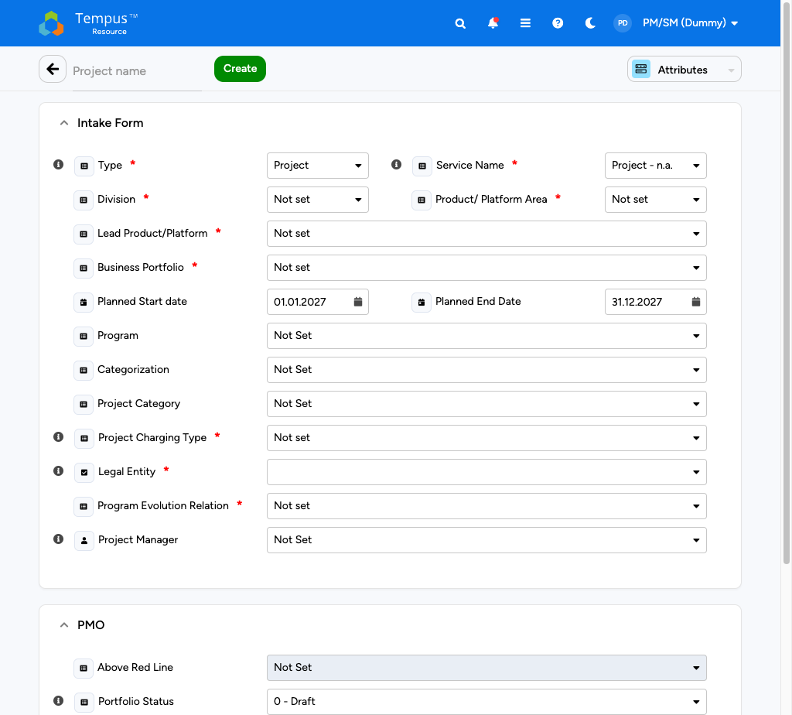
Create Project dialog (Intake)

Path A — Create without a template
Use this path for services, BAU work and any project where you do not want to inherit predefined attributes or assignments.
How to
1. From the Homescreen, click the + on the Project Management tile (or + Add projects in the grid).
2. In the dialog, choose Create blank project (no template selection).
3. Enter the Project name. Knauf naming convention: <Project type abbreviation> – <short scope>, e.g. BAU – AD Hardening 2026.
4. Set the Start date and End date. These must be valid before the Single Project Allocation grid will accept assignments.
5. Confirm with Create. Tempus opens the new project's Attributes page automatically.
6. Continue with chapter 5 — Set up Attributes — to fill the mandatory master data before moving to Resources and Financials.

Note: A blank-project shell is created in status Intake / Draft until the mandatory attributes (chapter 5) are filled. You can save and come back, but the project will not show up in dashboards until status is moved to Active and the owner is assigned.

Path B — Create with a template (PMO project)
Use this path when an Intake item has been approved by the Knauf PMO, or when a standard project profile applies (e.g. "Knauf IT Standard Project").
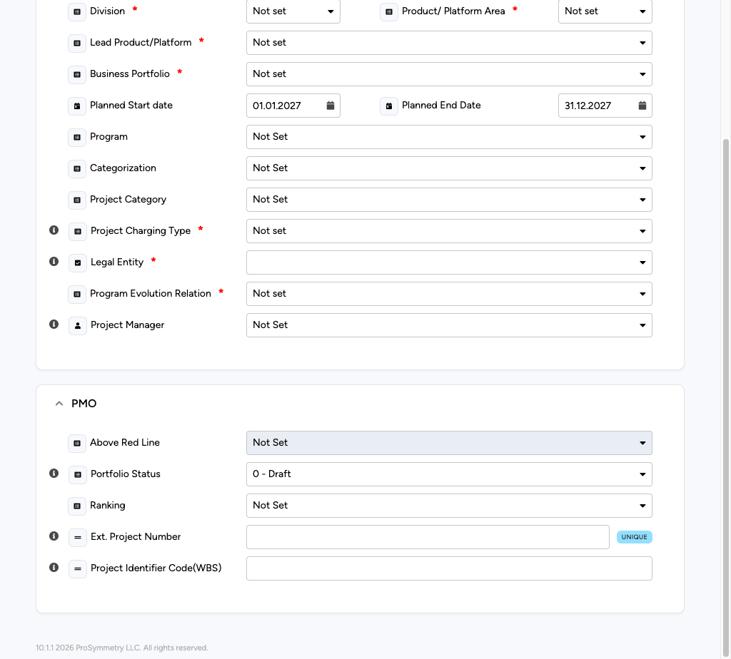
Create Project from PMO template
How to
1. From the Homescreen, open Project Management and click + Add projects → Create from template.
2. Pick the relevant template — the Knauf default templates are listed alphabetically, prefixed with TPL_.
3. The dialog pre-fills:
4. Project status (Active or Planning, depending on template)
5. Default attribute values (Business Unit, Phase, Cost Center, ...)
6. A predefined task structure on the Allocation grid (e.g. "Specification / Build / Test / Hypercare")
7. Override Project name, Start/End date, and Project owner as needed — these are the four fields that are almost always template-specific.
8. Click Create. Tempus opens the new project on the Attributes page.
9. Walk through chapters 5–7 once to validate the inherited values; in 80 % of cases you only adjust dates and owner.

Note: Tip — bulk-fill: If you create several similar projects in a row (typical at the start of a fiscal year), use the Clone action on an existing project from the grid instead of going through the template dialog every time.

What happens after Create
On a successful Create, Tempus drops you straight onto the new project's Attributes page. From here the path is always the same:
1. Attributes — fill the master-data fields (chapter 5).
2. Resources — open the Single Project Allocation grid and add the planned demand (chapter 6).
3. Financials — set the rate card, the Cost Plan, and the Budget (chapter 7).
4. Save & Check-in — release your check-out so other Planners can edit, and the figures appear in dashboards (covered at the end of chapter 6).
Warning: Until you save and check in, the project is invisible to RM Resource Requests and to Reports. A brand-new project that is never checked in will sit silently in your drafts without any visibility.

Pillar 1 — Attributes (Master Data)
PM/SM | Blended PM/SM + PPM

Attributes describe what the project is. Every report, every dashboard tile and every Resource Request inherits from attributes — incorrect master data here makes the rest of the tool unreliable.
This chapter applies to both moments:
- When you have just created a project (chapter 4 → continue here).
- When you have opened an existing project and need to update master data (chapter 8 → comes back here).
The page itself, the fields, the edit-loop and the validation are identical.

The Attributes page at a glance
After Create, Tempus opens the project shell with the Attributes tab active. The layout has three zones:
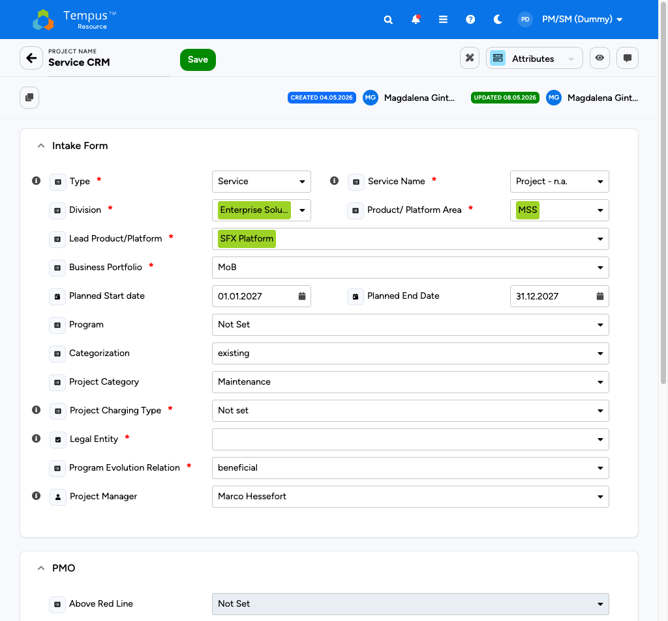
Attributes page layout
At a glance
• Top — Project header with project name, status pill, project owner, start/end dates and the Check-out / Check-in button.
• Left — Attribute groups ("General", "Classification", "Time & Money", "Custom" — Knauf-specific group labels may differ slightly per template).
• Centre — Attribute fields, grouped by the section selected on the left. Required fields are marked with a small red asterisk.
• Right — Audit & Activity column (recent changes, last edited by, version pin).

Note: Check-out is automatic as soon as you start editing an attribute, provided no one else holds the lock. The header switches from a green Available pill to a yellow Checked out by you pill.

What to maintain at create time
The Knauf go-live scope expects PM/SM to populate these fields on every new project. Templates pre-fill many of them, but always verify.
Group | Field | Why it matters | PM/SM-fillable?
General | Project name | Identifies the project everywhere | Yes
General | Project type | Standard / Service / BAU / Non-project (Admin, Run …) | Yes (limited list)
General | Status | Drives visibility on the grid and in reports | Yes — see status flow below
General | Project owner | Default Planner used in Quick Filters | Yes
Classification | Business unit | Cost-center alignment | Yes
Classification | Phase | Drives template lifecycle (Intake → Planning → Active → Hypercare → Closed) | Yes
Time & Money | Start / End date | Boundaries of the SPA grid | Yes
Time & Money | Currency | EUR by default at Knauf | Read-only (admin)
Custom | Risk profile / Strategic flag / Vendor | Knauf-specific reporting | Yes

Editing rules (single project)
The page is a classic edit-many, save-once form — there is no per-field save, but you must trigger Save before you leave the page or the changes are dropped.
How to
1. Click into the field you want to change. Tempus auto-checks out the project on first edit (yellow pill appears in the header).
2. Make as many changes as needed across the attribute groups on the left.
3. Click Save in the top-right of the page.
4. Wait for the green confirmation toast in the lower-right corner. If validation fails (mandatory field missing, invalid date range, …) the toast is red and the offending field is highlighted with a red border.
5. When all changes are saved, Check-in to release the lock. Other PM/SM can now edit; reports refresh on their next scheduled run.

Note: Tip — keep yourself short: the typical Knauf edit loop touches 2–3 fields (e.g. Status, End date, Risk profile). Don't open the page with the intent to clean all groups in one sitting; you will create more lock contention than value.

Project status flow (PM/SM-controllable)
The status field has tight rules — Tempus blocks invalid transitions with a red toast. The legal path for PM/SM:
From | To | Trigger / requirement
Draft | Active | All mandatory attributes filled; owner set
Active | On Hold | Optional, reversible
On Hold | Active | Reverses the hold
Active | Closed | End date reached AND all assignments checked out by RM
Closed | Re-open | Only by PMO admin, not PM/SM

Warning: Setting a project to Closed freezes the Allocation grid and the Financials page. Make sure all planned hours/costs are checked in before closing — there is no PM/SM bypass.

What PM/SM cannot see or edit
A few fields and pages remain RM- or admin-only at Knauf in Phase 1. They are visible on the page (grey) so you know they exist, but the field is read-only or the icon is greyed out.
Read-only for PM/SM | Owned by
Resource Rate Card overrides (per-resource) | RM / Finance
Resource Manager assignment per role | RM
Audit-log purge | Admin
Custom attribute schema changes | Admin
Lock-period setup | Finance admin

If you genuinely need one of these changed, open a Resource Request with comment, or contact the PMO directly.

Cross-references
- After Attributes, continue with Resources (chapter 6) — the same project, but now on the Allocation grid.
- For Financials (rates, Cost Plan, Budget), see chapter 7.
- To return here from the Project Management Grid later, see chapter 8 — the edit loop is identical to the one above.

Pillar 2 — Resources (Allocations)
PM/SM | Blended PM/SM + PPM

Resources answer the question who works on this project and how much. PM/SM at Knauf plan demand using the Single Project Allocation (SPA) grid. The same grid is used at create time (initial planning) and during the project lifecycle (re-planning, re-forecast).
This chapter walks through the grid layout, the standard "add a resource" loop and the most important grid options. Bulk Project Allocation (BPA) is a different grid for RM and is intentionally out of scope.

Opening the Allocation grid
From the project's Attributes page (chapter 5), switch to the Allocation grid via the view selector in the top-right corner of the project header (it lists Attributes, Allocations, Financials, Audit, …). Pick Allocations.
Note: The Allocation grid only becomes editable once the project has a valid Start and End date on the Attributes page. If you forgot to set them at Create time, you will see a placeholder banner instead of the grid — go back to Attributes and fill the dates.

SPA grid at a glance
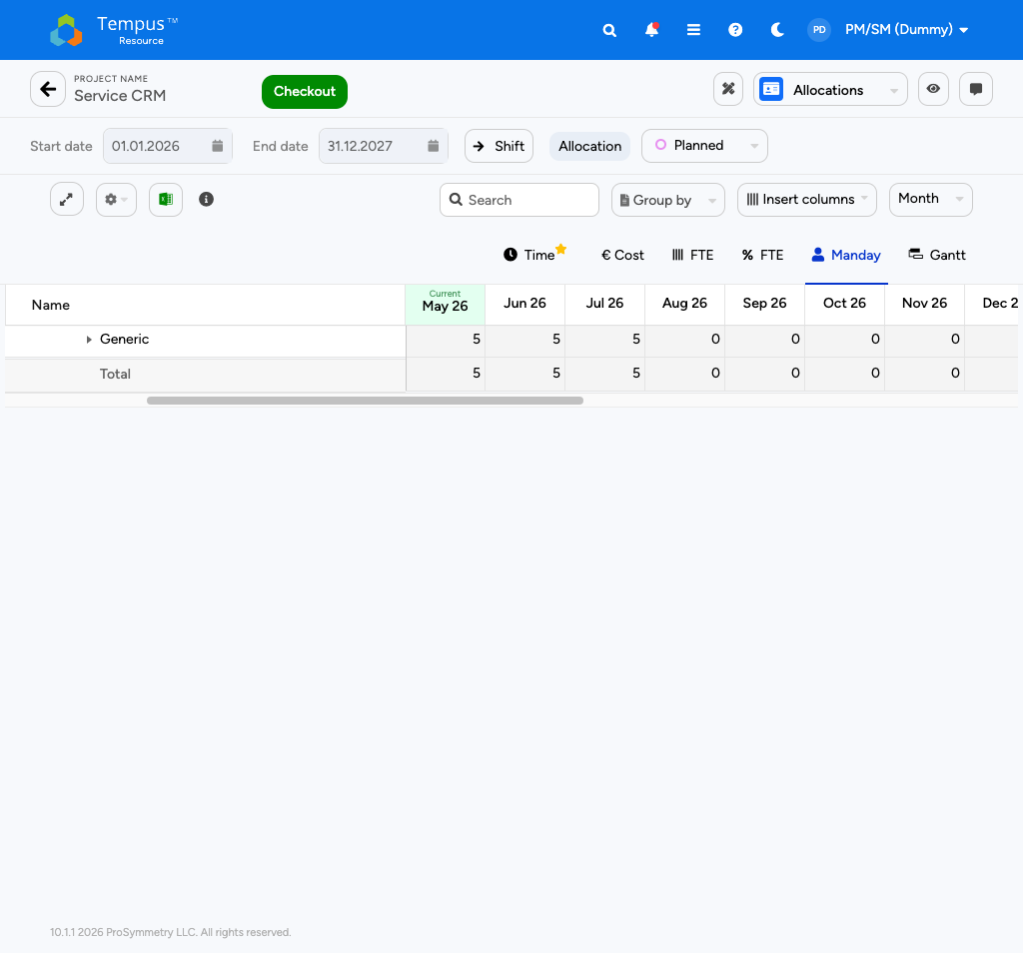
SPA grid in manday view
At a glance
• Header strip — project name, Check-out / Check-in button, planned status pill (PLANNED / BASELINED), Start/End date.
• Ribbon — main grid controls (Expand, Search, Group by, Insert columns, Time granularity, Capacity unit, Options menu).
• Body — rows of resources/tasks, columns of time buckets (months by default).
• Right gutter — totals (Total Hours, Total Mandays, FTE average, depending on capacity unit).

How to add a resource
The standard add-resource loop at Knauf:
How to
1. Click Check-out in the header (yellow pill appears — only you can edit).
2. Click + Add Row above the grid body and pick the resource type:
3. Named resource — a specific person from the Resource pool. Use when you already know who will work on the project.
4. Generic / role-based resource — a placeholder ("Senior Dev DE", "Tester IN") that triggers a Resource Request to the RM later. Use when staffing is still open.
5. The new row appears with zeros in every time bucket.
6. Type the allocation directly into the time buckets you want to load. Tab moves right (next month), Enter moves down (next resource).
7. Repeat for additional resources.
8. Click Save — wait for the green toast.
9. Click Check-in — releases the lock. Generic rows now trigger Resource Requests automatically; named rows go into the RM's approval queue.

Note: Tip — bulk fill: select a range of cells with Shift+click, then type a value and press Enter — the value is replicated across all selected cells. Combined with Group by Resource this is the fastest way to load standard demand for a 12-month service project.

Ribbon options PM/SM use most
Control | What it does | Knauf default
Expand | Toggles the grid into full-screen mode | Off
Search | Searches within the grid (resource name when grouped by resource, task name when grouped by task) | Empty
Group by | Switch between Resource and Task grouping | Resource
Insert columns | Adds project, resource or assignment attributes as columns (Cost Center, Role, Status …) | Role + Status
Time granularity | Month / Quarter / Year (Week is RM-only) | Month
Capacity unit | Hours / Mandays / FTE / FTE % | Hours (PM/SM views also show Mandays)

Options menu (Advanced)
Open the Options drop-down in the ribbon to reach the more advanced display toggles. All of them affect only your view, never other Planners.
Option | What it does | When to enable
Total Column | Adds a final column with the total Hours / Mandays per row | Always on at Knauf
Resource Heatmap | Background colour per cell based on overall allocation % of the resource | Useful when validating named resources against their other commitments
Resource Request Heatmap | Background colour based on Resource Request status (Pending / Approved / Rejected) | When chasing approvals before go-live of a project
Overlay Heatmap — Rows / Groups | Applies the selected heatmap to individual rows or groupings | Match the visualisation to your "Group by" choice
Tasks to show | Filters _generic vs. non-generic tasks | Hide generics during go-live freeze
Date Range Filter | Limits the grid to a sub-range without changing the project timeframe | Quarterly re-forecast loop

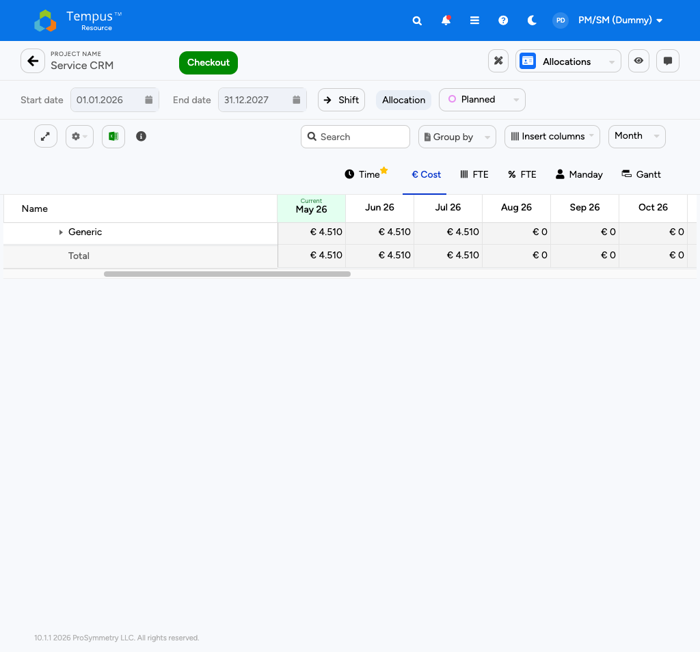
Cost view with Cost Plan overlay

Switch between Manday and Cost view
PM/SM commonly toggle between the two main views of the same SPA grid:
View | Capacity unit | Used for
Manday view | Hours or Mandays | Discussion with Project Owners, Resource Managers, status reports
Cost view | Cost (calculated from the rate card) | Discussion with Finance and PMO; cross-check against Financials page

The switch is a single click on Capacity unit → Cost; no save needed. Behind the scenes Tempus multiplies each cell's hours by the resource's Hourly Rate (chapter 7) and shows the resulting Cost.
Tip: Toggle Cost view briefly at the end of every planning session — anomalies (e.g. a senior architect accidentally loaded at junior rate) jump out immediately.

Save & Check-in — the discipline
Every change must be saved + checked in to be visible to the rest of Knauf:
Action | What it does | What it does NOT do
Save | Persists your edits | Does not release the lock; reports still don't see the changes
Check-in | Releases your lock; recalculates totals; triggers RM Resource Requests | Does not save unsaved edits — always Save first

Warning: A check-out left open at end of day blocks other Planners. The Knauf rule is: always check in before lunch and before sign-off. If you forget, an admin can force-release the lock, but you will lose unsaved edits.

Pillar 3 — Financials
PM/SM | Blended PM/SM + PPM

Financials answer what does this project cost, and is it on budget. At Knauf, PM/SM are accountable for the Cost Plan and the Budget vs. Actual comparison; rates and lock periods are administered by Finance / PPM but must be understood by every Planner.
This is the pillar most often skipped at Create time — and the one that pays off the most when you do it properly at the start. Plan once, re-forecast quarterly.
At a glance
• Hourly Rate — single value per resource (admin-maintained).
• Advanced Rate — time-and role-dependent rate card (admin-maintained).
• Cost Plan — derived from the Allocation grid × the applicable rate. PM/SM-editable for adjustments.
• Budget vs. Actual — Cost Plan as Plan; actual logged hours × rate as Actual.
• Lock Periods — closed months/quarters where Cost cannot be changed.
• Re-forecast — PM/SM-driven update of remaining quarters' Cost Plan.

Opening the Financials page
From the project header (Attributes, Allocations, …), choose Financials in the view selector. The page shows three stacked panels:
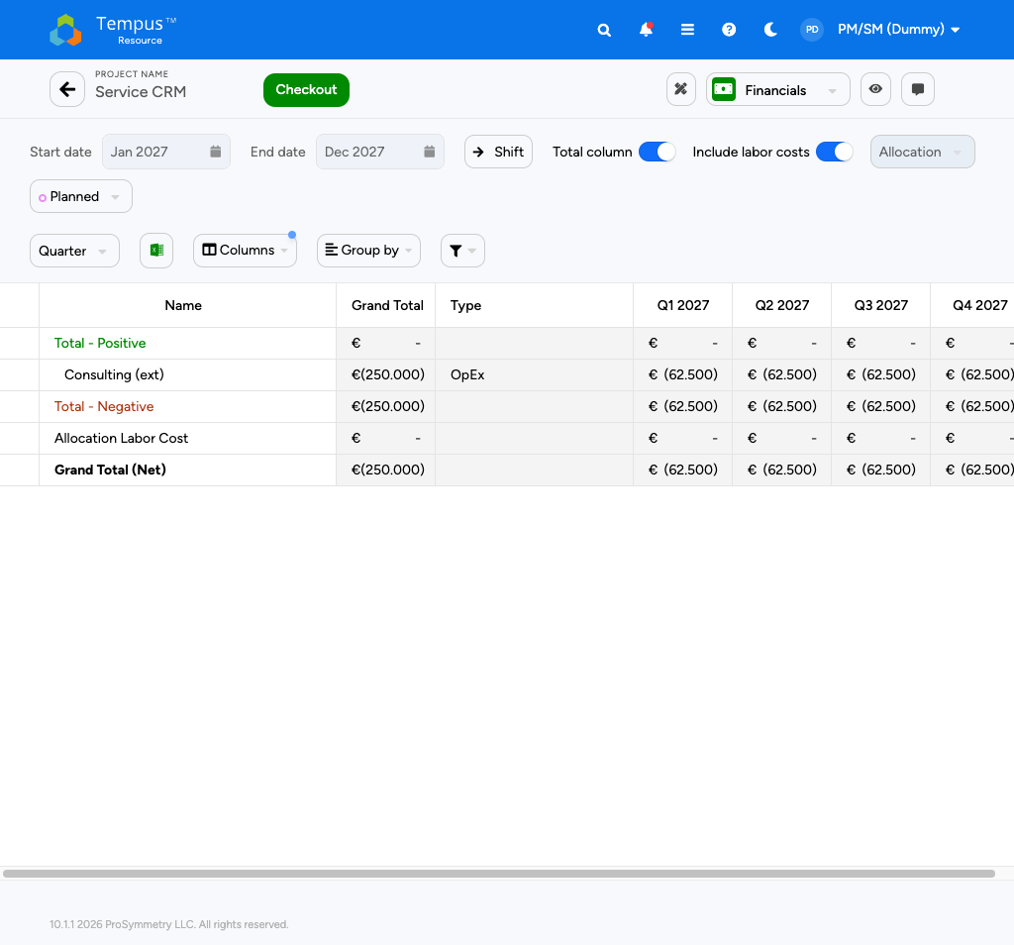
Financials page with Cost Plan and Budget
Panel | Shows | Editable by PM/SM
Rate Card | Hourly Rate per resource (or per role for generics), with effective dates | No — read-only reference
Cost Plan | Calculated cost per resource × month from the Allocation grid | Yes — manual override per cell allowed
Budget vs. Actual | Plan (Cost Plan) vs. Actual (logged hours × rate) per month / quarter / year | Plan editable; Actual read-only

1. Hourly Rate
The Hourly Rate is the simplest rate model — a single rate per resource, valid for a date range. Knauf uses it for:
- Named resources whose rate does not change with the activity (e.g. "Lina Vorontsova — Senior Architect — 145 €/h").
- Generic / role-based resources where a single blended rate is acceptable (e.g. "Senior Dev DE — 120 €/h").
PM/SM can read the Hourly Rate in the Rate Card panel and in any Allocation-grid column. To change it, request a rate update from Finance — there is no PM/SM-side override on the Hourly Rate.
Note: Hourly Rate is the fallback rate. If no Advanced Rate applies for a given month/role, Tempus uses the Hourly Rate.

2. Advanced Rate
The Advanced Rate is a richer rate model — multiple rates for the same resource depending on time (effective from / to) and on role / activity. Used at Knauf for:
- Annual rate uplifts (e.g. 2026 rate jumps to 150 €/h on Jan 1).
- Cross-charging where the rate depends on the role the resource is playing (Lead vs. Reviewer).
- External vendors whose rate is contract-bound and changes per phase.
Advanced Rate is administered by Finance. PM/SM see the resolved rate in the Cost view of the Allocation grid (chapter 6) and in the Cost Plan panel below.
Note: Tip — when the Cost number surprises you: open the Insert columns dropdown on the SPA grid and add the Effective Rate column. The grid will show which rate row (Hourly vs. Advanced, which date band) Tempus actually used per resource — the most common source of "wrong-cost" tickets.

3. Cost Plan
The Cost Plan is the financial twin of the Allocation grid. Whenever you save and check-in on the SPA grid, Tempus recalculates the Cost Plan cell-by-cell as:
`` Cost Plan[resource, month] = Hours[resource, month] × Effective Rate[resource, month] ``
For most planning sessions you do nothing here — the Cost Plan is correct because the Allocation grid is correct. The two cases where PM/SM manually adjust the Cost Plan:
Reason to override | Example
Fixed-price line item not driven by hours | A vendor invoice of 25 k€ in Q2, irrespective of effort
One-off cost (license, hardware) | 8 k€ Tableau license in Jan
Currency adjustment manually applied | A foreign-currency external is being billed at a non-standard rate

How to
1. On the Financials page, in the Cost Plan panel, click into the target cell (resource × month).
2. Enter the override value. The cell shows a small "manual override" indicator (orange dot at the corner).
3. Click Save in the panel header, then Check-in at the project header.
4. If you need to revert to the calculated value, right-click the cell → Reset to calculated.

Warning: A manual override survives changes to the Allocation grid — if you later add hours to that resource/month, your override is still shown and the calculated value is hidden. Reset overrides when they no longer apply.

4. Budget vs. Actual
The Budget vs. Actual panel compares the Cost Plan (Plan) to the Actuals (logged hours × applicable rate). Three flavours are available via the panel's view selector:
View | Granularity | Used for
Monthly | One bar per month | Operational tracking
Quarterly | Q1 / Q2 / Q3 / Q4 | Standard Knauf status meeting
Annual | Single Plan / Actual total | Year-end close, audit

Note: Actuals at Knauf are loaded from the Timesheet system once a week (Sunday night batch). A spike in Actuals on Monday morning is normal — it includes the previous week's bookings.

The Variance column is colour-coded:
Colour | Meaning | Knauf threshold
Green | Actual within ±5 % of Plan | OK
Amber | Variance ±5 % to ±15 % | Flag in next status report
Red | Variance > ±15 % | Escalate to PMO; trigger re-forecast

5. Lock Periods
A Lock Period is a date range (typically a closed financial month or quarter) in which Cost cannot be changed. Lock Periods exist to protect month-end reporting from retro-active edits.
State | Symbol on the grid | What you can do
Open | No symbol | Edit freely
Soft-locked | Padlock outline | Edit with a comment (audit-tracked)
Hard-locked | Filled padlock | Read-only; no edit possible without PMO override

Warning: At Knauf the previous month is soft-locked on the 5th business day of the following month and hard-locked on the 10th. Schedule your Cost Plan adjustments before those dates. Soft-locked edits are tracked and reported to Finance.

6. Re-forecast
A Re-forecast is a structured update of the Cost Plan for all remaining open months/quarters of a project. The Knauf cadence is quarterly:
How to
1. Trigger — at the start of each quarter, PMO publishes the re-forecast window (typically two weeks).
2. Open the project's Financials page and switch the Budget vs. Actual view to Quarterly.
3. Compare Actuals vs. Plan for the closed quarter. Red and amber rows are your candidates for adjustment.
4. Adjust the Cost Plan for the remaining quarters — preferably by editing the Allocation grid (chapter 6) so hours and cost stay in sync. Use manual Cost Plan overrides only for non-hour-driven items.
5. Save & Check-in — the new Plan becomes the active baseline for the next quarter's reporting.
6. Comment — leave a short note on the Audit pane (right column) summarising what changed and why. PMO uses these comments in the quarterly variance review.

Tip: Don't re-forecast a project the day before status meeting — the new figures land in dashboards on the next overnight refresh, and you want the PMO to see the same Plan you discuss.

What PM/SM cannot edit on Financials
Read-only / admin-only | Owner
Rate Card values (Hourly + Advanced) | Finance admin
Effective-date bands on the Rate Card | Finance admin
Currency configuration per project | PPM admin
Lock-period schedule | Finance admin
Actuals correction (timesheet adjustment) | Time-tracking admin

If you spot a Rate Card error or an Actual you believe is wrong, document it in the Audit pane and raise the ticket with Finance — there is no PM/SM-side workaround.

Find and Open a Project
PM/SM | Blended PM/SM + PPM

The second daily workflow is find an existing project and edit it. Mechanically, the edit pages are identical to the Create-time pages you already know:
- Attributes → chapter 5
- Resources → chapter 6
- Financials → chapter 7
This chapter therefore only covers what is different in edit mode: the Project Management Grid (how to find the project) and the Open mechanics (how to land on the right tab the first time). For everything that happens after that, jump back to the relevant pillar chapter — the edit-loop instructions are intentionally the same.

Project Management Grid
From the Homescreen, click the Project Management tile. You land on the Project Management Grid — your repository of all visible projects.
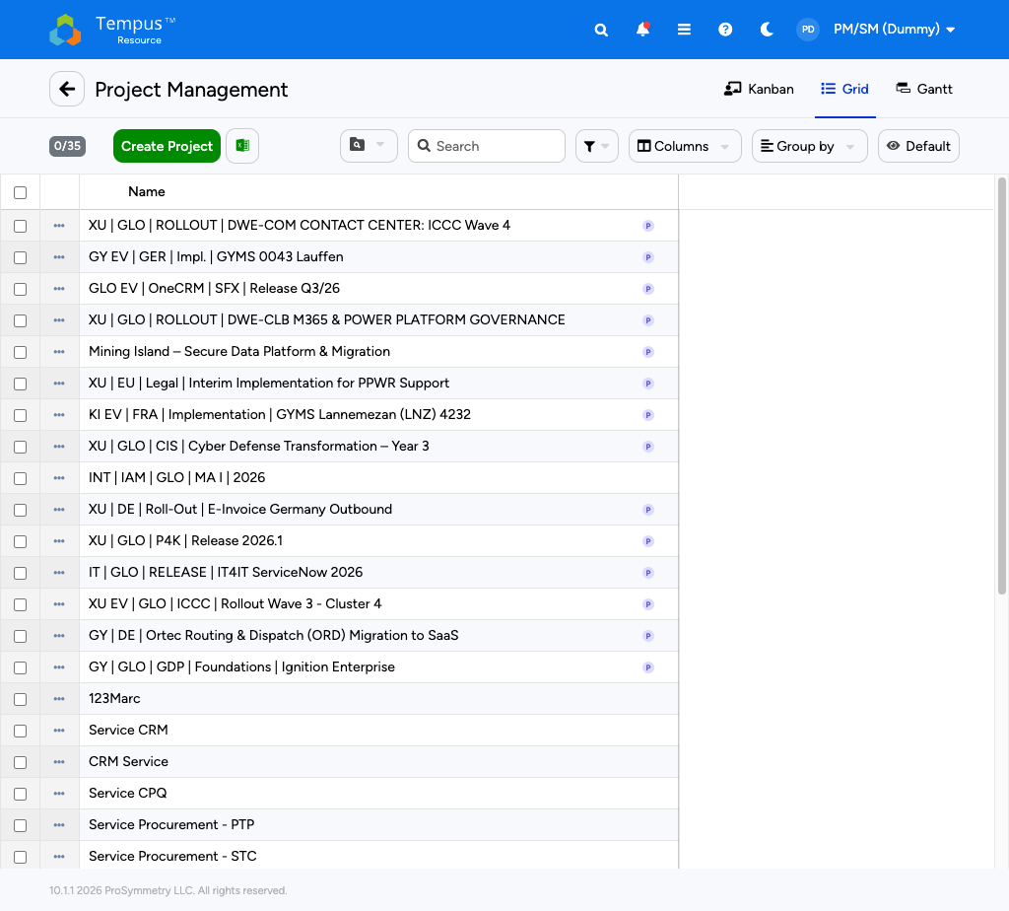
Project Management Grid with toolbar
At a glance
• Toolbar — + Add projects (chapter 4), Search, Filter, Insert columns, Group by, View selector.
• Body — one row per project, with the columns of the currently selected view.
• Row actions — hover a row to reveal the ⋯ More menu (Open, Clone, Delete-if-empty).

View Management
A View is the saved combination of: selected columns, applied filters, group-by setting and sort order. Knauf ships a small set of public views; PM/SM can clone them into personal views.
View type | Icon | Editable by you | Typical use
Public view | Blue eye | No — read-only | "All Active Projects", "My Department — Standard", PMO master views
Public default | Star (filled) | No | The view you land on when you open the grid
Personal view | Pencil / private | Yes | Your personal filter, e.g. "My projects, this quarter only"
Personal default | Star (outline) | You set it | One personal view auto-loads on grid open

How to
1. Open the View drop-down (top-right of the grid toolbar).
2. To save your current filter + columns: Save as new view → name it → choose Private.
3. To start from a public view: Clone the public view → adjust → save as private.
4. To set a personal default: open your view → click the star icon next to its name in the drop-down.

Tip: Don't fight the public views — clone them. Public views are versioned by the PMO and updated globally; your personal clones are immune from those updates.

Search, Filter and Quick Filters
Control | Behaviour
Search bar | Searches the Project name column with contains logic
Filter | Adds column-level filters; multiple filters are AND-combined
Quick Filters | Predefined buttons in the toolbar — My projects, Active, This quarter, Owner = me, Recently changed
Group by | Group by any attribute; multi-level grouping supported (e.g. Phase → Owner)

Note: My projects uses the owner attribute on Attributes (chapter 5). If a project is missing from your My projects view, check the owner field first — it is almost always wrong-attribution, not a Tempus bug.

Open a project
Two ways to open a project from the grid:
Action | Lands on | Use when
Click the project name (left-most column) | Attributes page | You want to start with master data
Hover the row → ⋯ More → pick Allocations / Financials / Schedule / … | The chosen tab | You know exactly which tab you need

Advanced tooltip — direct deep-link
Hovering over any project name shows an Advanced Tooltip with shortcut icons to all areas of that project that you have access to (Attributes, Allocations, Audit Log, Build Team, File Management, Financials, Milestones, Project Risk Profile, Schedule, Sheets, Snapshots).
How to
1. Hover the project name in the grid — the Advanced Tooltip opens.
2. Click the area icon you want (e.g. Financials).
3. Tempus opens the project directly on that tab, skipping the default Attributes landing page.

Tip: Bookmark the project URL after you've opened it once — Tempus URLs are deep-linkable to the exact tab (Attributes / Allocations / Financials / …). Pin a few high-traffic projects in your browser bookmarks for one-click access.

Edit loop — same as Create
Once a project is open, the edit-loop is identical to the Create-time setup:
If you are editing… | Go to | Edit-loop reference
Master data (owner, dates, status, classification, custom flags) | Attributes | Chapter 5
Resources (named, generic, manday, cost view) | Allocations | Chapter 6
Financials (Cost Plan overrides, Budget vs. Actual, Re-forecast) | Financials | Chapter 7

The Check-out / Save / Check-in discipline applies on every page — see the warnings at the end of chapter 5 (Attributes) and chapter 6 (Allocations).
Warning: Editing without check-in is the #1 source of "ghost changes" at Knauf — the edits live on your machine but never reach Reports. Always check in before you sign off, even if it's "just a quick fix".

Appendix
PM/SM | Blended PM/SM + PPM

A. Keyboard Shortcuts
Tempus uses a small set of Excel-like shortcuts. The ones PM/SM use most:
Shortcut | Where it works | Action
Ctrl + C / Ctrl + V | Any grid | Copy / paste cell content
Tab | Editable grids | Move to next cell on the right
Enter | Editable grids | Move down one row
Shift + Click | Grid headers / cells | Select a column / range
Drag the "+" handle (bottom-right of a selected cell) | Editable grids | Replicate value across the dragged range
Ctrl + S | Anywhere | Save current page (equivalent to clicking Save)
Ctrl + F | Grids | Open the in-grid search
Esc | Modals | Close without saving

B. Tempus Icon Reference (most used)
Icon | Meaning
Trash can | Delete selected item
Pencil | Edit / view selected item
Copy / Clone | Duplicate selected item
Lock / Unlock (open / closed padlock) | Whether record is locked by another user
Excel / CSV / PDF | Export the current view
Filter funnel | Apply column-level filter
Bell | Notifications — red dot = unread
Blue eye | Public (read-only) view
Star (filled) | Default view
Demand-resource silhouette | Generic / role-based resource row
Proposal marker | Resource on a project in Planning status

C. Status Pills
Pill | Where | Meaning
Available (green) | Project header | Page is not checked out — anyone can edit
Checked out by you (yellow) | Project header | You hold the lock
Checked out by <name> (yellow w/ avatar) | Project header | Someone else is editing — read-only for you
Planned / Baselined | SPA grid header | Project's allocation has a baselined version
Draft / Active / On Hold / Closed | Attributes header | Project status (see chapter 5 status flow)

D. What PM/SM Cannot See or Edit (Phase 1)
A quick lookup of fields and pages that are intentionally hidden or read-only for PM/SM in the Knauf Phase 1 rollout. Owners listed are the right contact when something needs to change.
Restricted item | Owner
Resource Rate Card overrides (per-resource) | RM / Finance
Resource Manager assignment per role | RM
Bulk Project Allocation Flatgrid | RM (separate guide)
Resource Replace (per project & advanced) | RM
Rate Card values (Hourly + Advanced) | Finance admin
Effective-date bands on the Rate Card | Finance admin
Currency configuration per project | PPM admin
Lock-period schedule | Finance admin
Actuals correction (timesheet adjustment) | Time-tracking admin
Custom attribute schema changes | Admin / PPM
Audit-log purge | Admin

E. FAQ
Q: I saved an attribute change but it's not visible in the report. A: You probably forgot to Check-in. Save persists the value to your draft; Check-in releases the lock and triggers downstream visibility. Open the project → click Check-in → wait for the green toast → refresh the report.
Q: The Cost shown in the Allocation grid (Cost view) is different from the Cost Plan on the Financials page. A: You very likely have a manual override on the Financials page that does not match the calculated hours × rate. Open Financials → look for orange-dot cells in the Cost Plan panel → either right-click → Reset to calculated, or update the Allocation grid to match.
Q: I want to delete a project I just created. A: PM/SM can delete a project only as long as it has no assignments and no actuals. Open the grid → hover the row → ⋯ More → Delete. If Delete is greyed out, the project already has data — contact PMO for archival instead.
Q: A resource shows red in the Heatmap — is that a Tempus error? A: No — the resource is over-allocated across all their projects (not just yours). Toggle to Resource Heatmap in Options to see the global picture; you typically need to discuss the conflict with the RM rather than change your plan unilaterally.
*Q: Why is my project missing from the My projects Quick Filter? A: The My projects filter uses the Project owner attribute. If you are not the owner — even if you are doing the planning — the project will not show up. Either ask the current owner to change it, or use Owner = me* via a custom filter.
Q: How do I revert a wrong save? A: Tempus does not have a global Undo. Two options: (1) Manually re-enter the previous value (you can see prior values in the Audit pane on the right of every project page) or (2) for SPA grid changes, ask an admin to restore the most recent baseline.

F. Glossary
Term | Meaning
Allocation | Planned demand of a resource on a project for a given period
Actual | Logged hours from the timesheet system, multiplied by the applicable rate to give Actual cost
Assignment | The link between a resource and a project (one row in the SPA grid)
Baseline | A frozen snapshot of the plan, used as the comparison point for variance
Blended (Knauf role) | PM/SM + PPM combination — full Planner scope plus Portfolio view
Check-out / Check-in | Lock / release mechanism that allows safe editing
Cost Plan | Hours × applicable rate, shown on the Financials page
Demand / Generic resource | A role-based placeholder ("Senior Dev DE") that triggers a Resource Request
Effective Rate | The rate Tempus actually used for a given resource × month (Hourly or Advanced)
Lock Period | A closed financial period — Cost cannot be changed (soft or hard)
Re-forecast | Quarterly update of the Cost Plan for remaining open quarters
Resource Request | RM workflow that approves a demand on a resource
SPA grid | Single Project Allocation grid — the per-project planning surface
Time grain / Time granularity | The bucket size on the grid (Month, Quarter, Year)
View | Saved combination of filters, columns, group-by and sort

